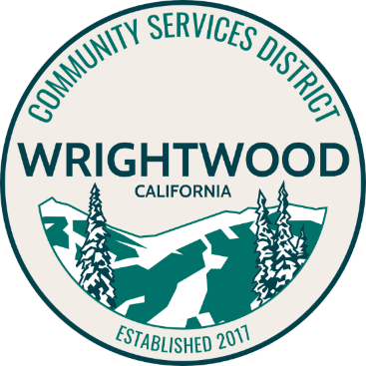
WRIGHTWOOD COMMUNITY SERVICES DISTRICT

Wrightwood CSD is looking for photographs, original artwork, or graphics to feature on our community dump card for 2021-2022. We are looking for landscape photographs that show off our town. Original artwork or graphics that depict our town are also welcome. In previous years we have chosen a photo to use as the background on the dump cards. This year we are asking the community, for their submissions, of what you love about our town.
Contest Rules

- The contest will run from November 1, 2020 through January 15, 2021.
- All submissions must be original – no material with a copyright will be accepted.
- Professional photographers, graphic artists or artists are not eligible.
- Landscape photographs only (no people in the photograph).
- Submissions must be submitted with a signed waiver.
- Submissions will not be returned.
- CSD staff may narrow the selection for the Board to consider depending on the number of submissions.
- The Board of Directors of the CSD will pick a winner during the February 2021 meeting.
- The winner will be featured on the CSD Facebook page along with their winning submission.
- Winner’s submission will be used as the background for the dump cards dated July 1, 2021 – June 30, 2022.
- Submissions need to be in .jpg format and are limited to 2 per person. Submissions are limited to 10MB.
- Submissions should be sent to gm@wrightwoodcsd.org and include the signed Release Form.

